Exploring Challenges and Opportunities for Africa’s Landscapes: A Pathway to Mitigating Drought Impact
● Date: November 12, 2025 (13:00 to 14:00 (GMT+00) / 14:00 – 15:00 (Bonn time / CET) )
● Language: English (with live French interpretation)
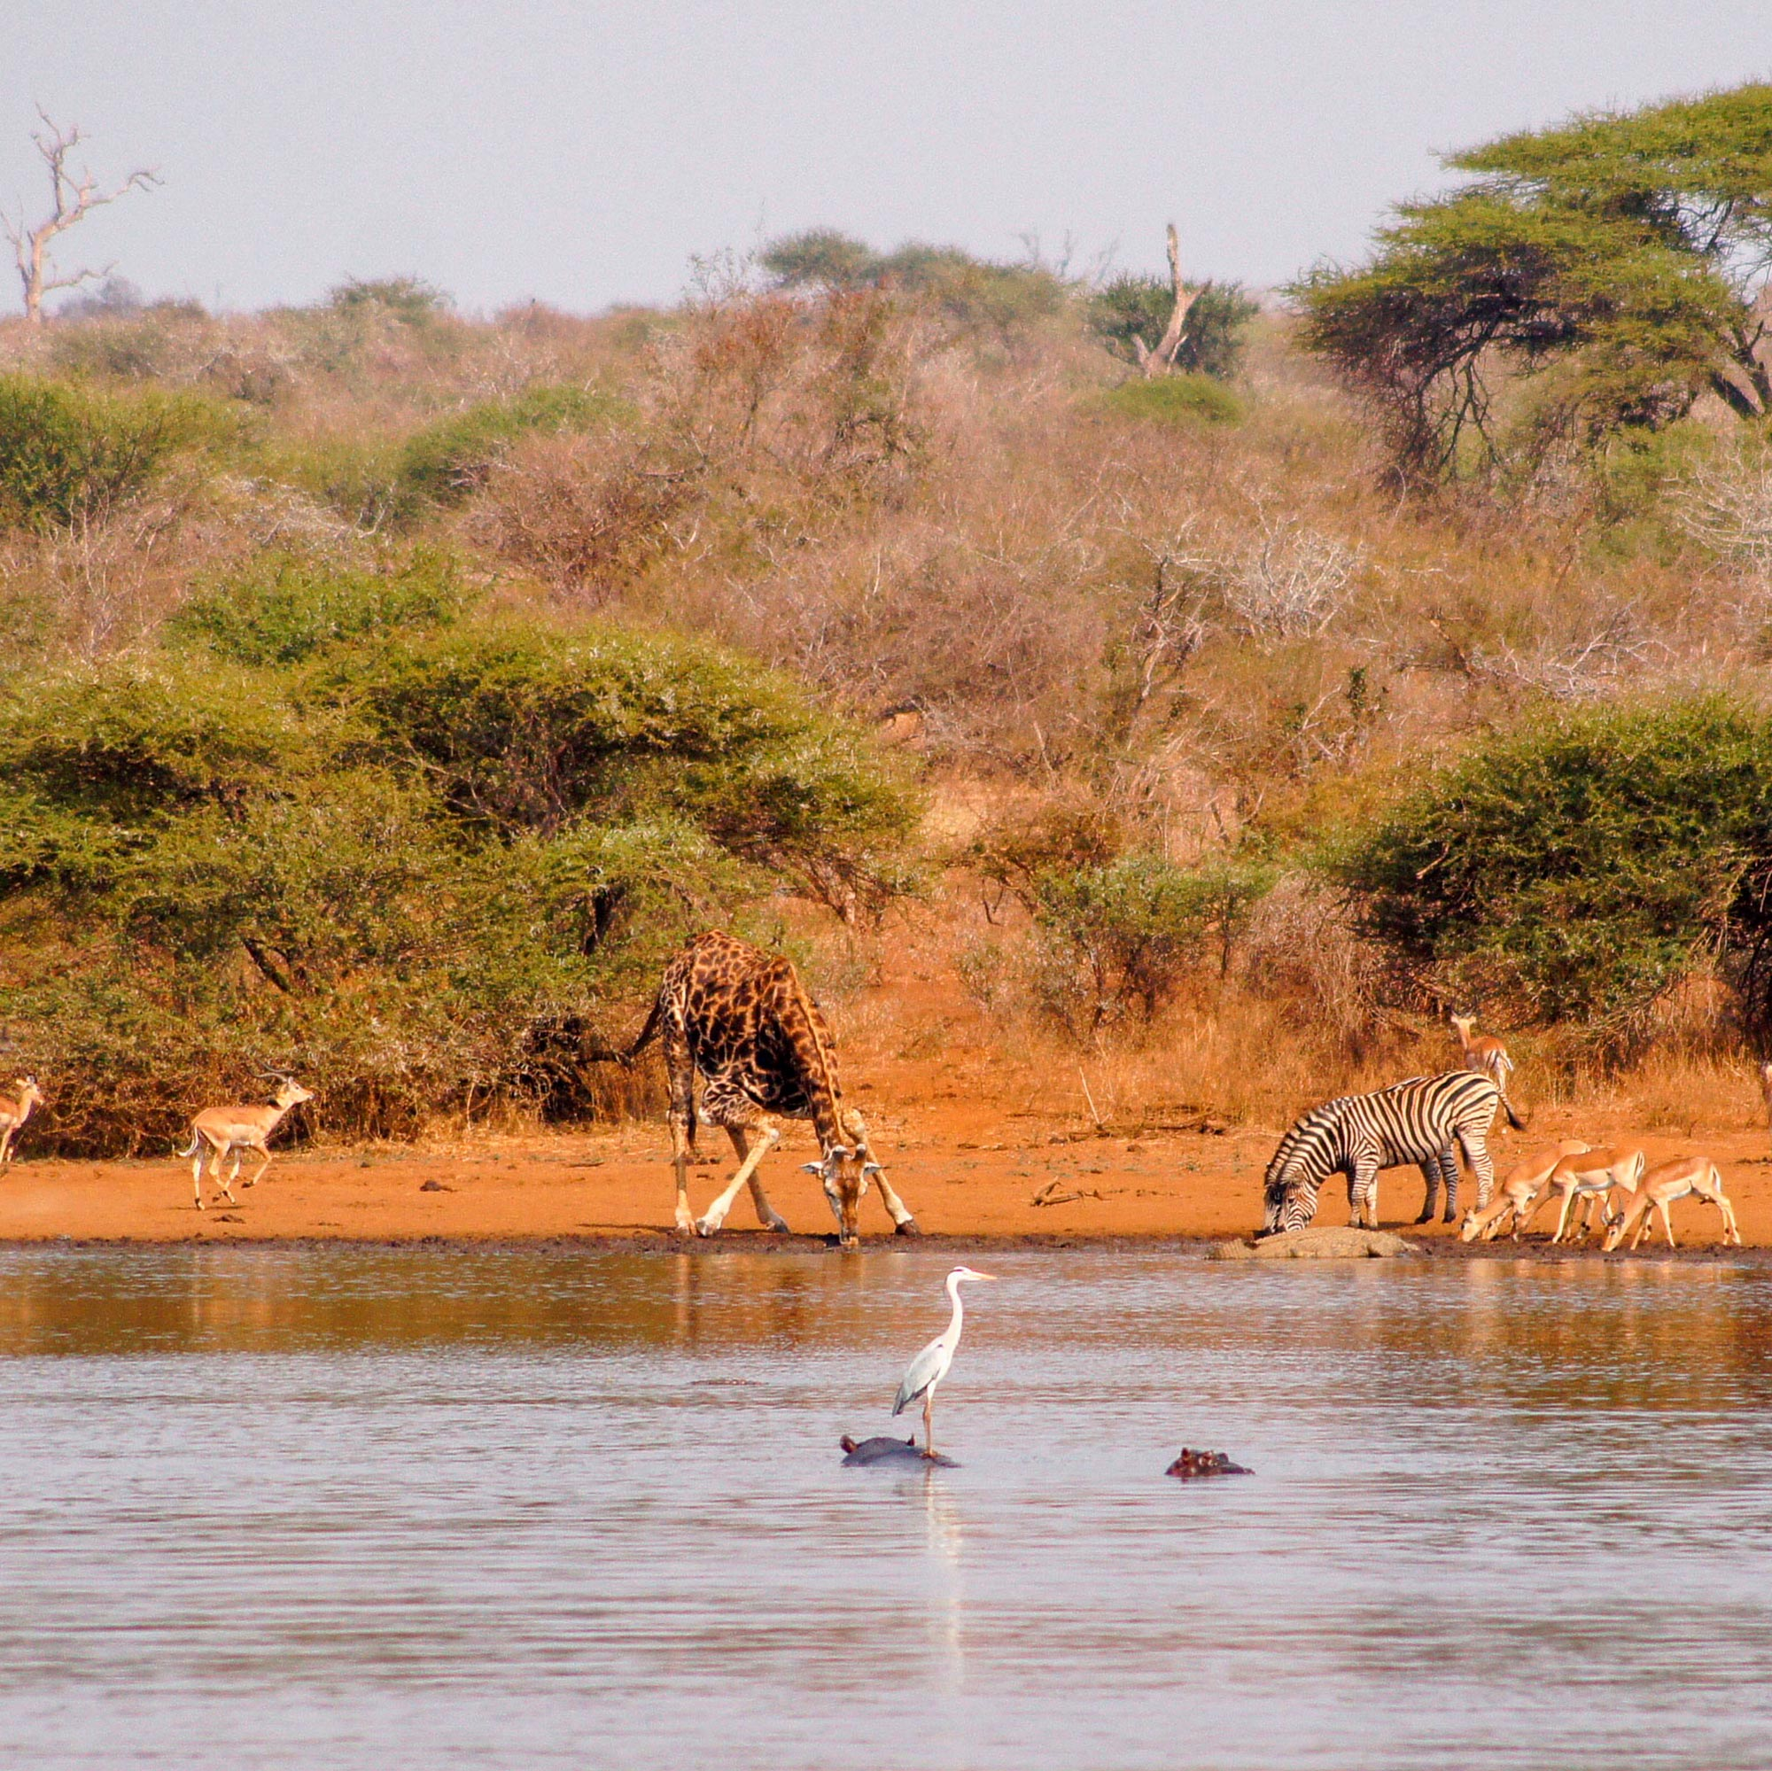Africa’s landscapes are at a critical crossroads. With over 45% of the continent’s land affected by desertification, the growing threats of land degradation, drought, and unsustainable land use are undermining food security, biodiversity, and livelihoods. Yet, Africa also holds immense potential for transformation—through ecosystem restoration, innovative land management, and community-driven resilience efforts.
This webinar, organized by UNCCD CLP-Africa, brings together experts, practitioners, policymakers, and youth leaders to explore actionable solutions for building drought-resilient landscapes. Participants will engage in rich discussions on water and soil management, the use of advanced technologies and remote sensing, and community-based innovations that are driving sustainable change across the continent.
Join us on 12 November 2025 to connect with changemakers shaping the future of Africa’s land and water systems. Together, we will share success stories, promote knowledge exchange, and chart a path toward a greener, more resilient Africa.

