Bibliography
Bazzana, D., Mobasser, A., & Vergalli, S. (2022). Less Water, Less Oil: Policy Response for the Kenyan Future, a CGE Analysis. Sustainability (Switzerland), 14(18). Scopus. https://doi.org/10.3390/su141811273
Cabot Venton, C. (2019). Economics of Resilience to Drought: Kenya Analysis. https://2017-2020.usaid.gov/sites/default/files/documents/1867/Kenya_Economics_of_Resilience_Final_Jan_4_2018_-_BRANDED.pdf
Cabot-Venton, C. (2018). Economics of Resilience to Drought: Summary. https://2017-2020.usaid.gov/sites/default/files/documents/1867/Summary_Economics_of_Resilience_Final_Jan_4_2018_BRANDED.pdf
CI. (2024). Honey value chain business cases capacity development, conservation international (TWENDE). Conservation International.
COMSTRAT. (2024). Capacity Development for selected TWENDE business cases Fodder/Grass Seed and Meat Value Chain in Kenya (TWENDE).
Cuevas, S., Pek, E., & Salman, M. (2024). Economic assessment of drought risk management. FAO. https://doi.org/10.4060/cc9981en
Gies, L., Agusdinata, D. B., & Merwade, V. (2014). Drought adaptation policy development and assessment in East Africa using hydrologic and system dynamics modeling. Natural Hazards, 74(2), 789–813. Scopus. https://doi.org/10.1007/s11069-014-1216-2
GoK. (2023a). Isiolo County Integrated Development Plan 2023-2027. https://nipfn.knbs.or.ke/isiolo/download/county-integrated-development-plan-2023-2027/
GOK. (2023). Marsabit 3rd-CIDP 2023-3027. https://www.marsabitassembly.go.ke/wp-content/uploads/2023/07/3rd-CIDP-Report-DRAFT-2.pdf
GoK. (2023b). SAMBURU CIDP-2023-2027. https://maarifa.cog.go.ke/sites/default/files/2024-06/SAMBURU%20CIDP-2023-2027.pdf
Herlocker, D. J., Shaabani, S. B., & Wilkes, S. (1993). Range Management Handbook of Kenya Volume 11,5 Isiolo District.
Heubaum, H., Brandon, C., Tanner, T., Surminski, S., & Roezer, V. (2022). The Triple Dividend of Building Climate Resilience: Taking Stock, Moving Forward. World Resources Institute. https://doi.org/10.46830/wriwp.21.00154
IUCN. (2019). Funding-proposal-fp113-iucn-kenya.pdf (p. 79). https://www.greenclimate.fund/sites/default/files/document/funding-proposal-fp113-iucn-kenya.pdf
Jarso, I., Tari, D., & King-Okumu, C. (2017). Recommendations to the County Government of Isiolo for Preparation of a Strategic Plan on Water, Energy and Climate Change. https://www.iied.org/sites/default/files/pdfs/migrate/10183IIED.pdf
King-Okumu, C. (2015). Pastoralism pays: New evidence from the Horn of Africa. https://www.iied.org/sites/default/files/pdfs/migrate/17312IIED.pdf
King-Okumu, C. (2016). Distilling the value of water investments The benefits of ward-level adaptations in the arid and semi-arid lands of Kenya. IIED. https://www.iied.org/sites/default/files/pdfs/migrate/17345IIED.pdf
King-Okumu, C., Wasonga, O. V., Jarso, I., & Salah, Y. M. S. (2016). Direct use values of climate-dependent ecosystem services in Isiolo County, Kenya. IIED.
King-Okumu, C. (2018). Valuing Environmental Benefit Streams in the Dryland Ecosystems of Sub-Saharan Africa. Land, 7(4), Article 4. https://doi.org/10.3390/land7040142
KNBS. (2024). 2025-2028 National Plan for the Advancement of Environmental-Economic Accounting (NP-AEEA) Strategic roadmap to guide seamless integration of the SEEA into Kenya’s statistical and policy frameworks. Kenya National Bureau of Statistics.
Lutta, I., Wasonga, O., Karanja, Saalu, & Njiru. (2020). Costs and benefits of sustainable rangeland management practices in Northern Kenya. https://www.eld-initiative.org/fileadmin/ELD_Filter_Tool/Case_Study_Kenya_2020/Kenya_2020_Rangelands_ELD_Case_Study_Report-EN.pdf
Managi, S., Chen, S., Kumar, P., & Dasgupta, P. (2024). Sustainable matrix beyond GDP: Investment for inclusive growth. Humanities and Social Sciences Communications, 11(1), 1–10. https://doi.org/10.1057/s41599-024-02659-5
Mukpo, A. (2025, January 31). Kenyan court orders two community wildlife conservancies shut down. Mongabay Environmental News. https://news.mongabay.com/short-article/2025/01/kenyan-court-orders-two-community-wildlife-conservancies-shut-down/
Muriuki, M. (2023). EFFECTS OF LAND USE CHANGES ON WATER AND VEGETATION MANAGEMENT IN LAGHA-BOR CATCHMENT, WAJIR COUNTY, KENYA by Moses Muriuki. Kenyatta University.
Schwartz, Shaabani, & Walther. (1991). Range Management Handbook of Kenya, Vol II No1: Marsabit District. GTZ. https://edepot.wur.nl/494272
Shaabani, S. B., Walsh, M., Herlocker, D. J., & Walther, D. (1992). Range Management Handbook of Kenya Volume 11,2 Samburu District. http://files.storiesofeastafrica.com/Volume+II/Range+Management+Handbook+of+Kenya+-+Vol.+II%2C2+-+Samburu/11_Vol+II%2C2+Samburu+District+-+Range+Management+Handbook+of+Kenya.pdf
Tanner, T., Surminski, S., Wilkinson, E., Reid, R., Rentschler, J., Rajput, S., & Lovell, E. (2016). The Triple Dividend of Resilience—A New Narrative for Disaster Risk Management and Development. In S. Surminski & T. Tanner (Eds), Realising the ‘Triple Dividend of Resilience’: A New Business Case for Disaster Risk Management (pp. 1–29). Springer International Publishing. https://doi.org/10.1007/978-3-319-40694-7_1
Tari, D., King-Okumu, C., & Jarso, I. (2015). Strengthening Local Customary Institutions: A Case Study in Isiolo County, Northern Kenya. Adaptation Consortium. https://www.celep.info/wp-content/uploads/2015/11/Strengthening-local-institutions.pdf
Thomas, Davies, J., King, C., Kruse, J., Schauer, M., Bisom, N., Tsegai, D., & Madani, K. (2024). Economics of drought: Investing in nature-based solutions for drought resilience – Proaction pays. UN Convention to Combat Desertification (UNCCD), Economics of Land Degradation (ELD) Initiative and United Nations University Institute for Water, Environment and Health (UNU-INWEH). https://doi.org/10.53328/INR24CCD001
van Zanten, Boris, Gonzalo Gutiérrez Goizueta, Luke Brander, Borja Gonzalez Reguero, Robert Griffin, Kavita Kapur Macleod, Alida Alves, Amelia Midgley, Luis Diego Herrera, & Brenden Jongman. (2023). Assessing the Benefits and Costs of Nature-Based Solutions for Climate Resilience: A Guideline for Project Developers. World Bank. https://openknowledge.worldbank.org/entities/publication/9ed5cb4b-78dc-42a4-b914-23d71cef24a2
Venton, P., Venton, C. C., Ward, C., Pischke, F., Engle, N., Wijnen, M., & Talbi, A. (2019). Framework for the Assessment of Benefits of Action/Cost of Inaction (BACI) for Drought Preparedness.
WRA, report not yet available
Wilkinson, E., & King-Okumu, C. (2019). Building resilience from the ground up. Disasters, 43(S3), S233–S244. Scopus. https://doi.org/10.1111/disa.12345
Yokomatsu, M., Mochizuki, J., Joseph, J., Burek, P., & Kahil, T. (2023). Macroeconomic co-benefits of DRR investment: Assessment using the Dynamic Model of Multi-hazard Mitigation CoBenefits (DYNAMMICs) model. Disaster Prevention and Management: An International Journal, 32(1), 139–162. Scopus. https://doi.org/10.1108/DPM-07-2022-0154

Year

Corresponding Author
Name and Surname of the primary corresponding author.

Organisation
Organisation of the primary corresponding author.

Corresponding Author Contact
Email address/contact details for the primary corresponding author.

Contributing Authors
Name and Surname of contributing authors. Please list up to 3 contributing authors.

Country*
- indicate a country according to the case study location. It is possible to indicate several countries.
- Drag to re-order taxonomy terms.

Region*
- Indicate one of the relevant GWP Regions, full list available as a drop-down on submission form. It is possible to indicate several regions.
- Drag to re-order taxonomy terms.

Keywords
- We invite you to add keywords which would help other users to find your case study via search. F.e., Drin River, rural, SADC, climate resilience, NDC etc.
- Drag to re-order taxonomy terms.

Supporting Materials
This section allows you to add multimedia content to support your case study. Allowed media types: Audio file, Document, Image, Link, Embedded Video, Video file. The media materials will be displayed on the right-side pane for each case study page once published.
Table 1: With- and Without TWENDE Project Scenarios
 | Without NbS | With NbS but without governance support to NbS | With governance support better aligned to NbS
Livestock | Local livestock and those migrating in suffer during dry seasons and wiped out during major droughts  Effect worsening over time due to increasing frequency of droughts and degradation of land resources | Effects of droughts on livestock are buffered by local management practices but still significant due to poor compliance by external groups and conflicts causing restricted mobility for local herders.  Increased % of local livestock survive but conflicts with in-migrating herders still cause loss of animal and human lives | Local livestock retain health for longer preservation of drought reserves  Reduced conflict-related mobility restrictions– slow onset of effects on lactation and bodyweight during droughts and enable faster recovery.
Vegetation conditions | Degradation of VCI due to climate change, overgrazing and cutting trees for firewood & charcoal particularly during and after droughts | Slower increase due to local management practices – still constrained due to governance barriers.  Effects of droughts on VCI are buffered by local management practices but still significant due to poor compliance by external groups and conflicts causing restricted mobility for local herders. | Slower increase as governance barriers to NbS are reduced.  Effects of droughts on VCI are buffered more due to better preservation of drought reserves and conservation of trees to produce gum instead of charcoal  reduced conflict-related mobility restrictions– slower onset of vegetation impacts during droughts and faster recovery.
Access to water | Declining due to climate change and increasing extraction – particularly during droughts extraction peaks and reserves do not recover afterward. Lasting effects on water quality after droughts.  Increasing costs of water pumping and vending | Slower decline due to improved land conditions and management practices – costs of vending and pumping rise more slowly  Increase use of waterpans offsets some increasing costs of water vending  Sub-optimal due to constraints on mobility caused by conflicts and poor siting and management of water infrastructure by government | Slower decline as barriers to NbS reduced – costs of vending and pumping rise more slowly  Increase use of water harvesting and waterpans offsets more of the costs of water vending  Effects of drought reduced due to better siting and management of infrastructure
Carbon | Increase emissions during dry seasons and droughts due to pumping, transportation  Reduce carbon sequestration due to land degradation | Slower decline in carbon sequestration due to improved land conditions and management practices (still sub-optimal)  emissions of pumping and transportation rise more slowly | More carbon sequestration due to better land management effects on soil and vegetation conditions  Pumping increases more slowly and uses more renewable energies
Economy | Major crashes during droughts and slow recovery  Large number of people destitute & caught in poverty trap | Reduced crashes during droughts  Economy still lagging behind – underinvestment continuing due to path-dependence & risk aversion | Improved returns through sustainable value chains, accelerating reinvestment, jobs and diversification of assets  drought does not cause price crashes and destitution
Public expenditure | Continuous drain due to relief costs, insecurity, lack of tax revenue | Continuing costs of insecurity & poor public service provision | Reduced insecurity and improved investment in public services  Improved national and local public revenue and local institution-building

Table 2: Modelling and valuation methods
 | Modeling change | Valuation | Data inputs
Access to water | Increased capacity of storage tanks & pans  Increased recharge to springs &wells (SWAT) | Market price  Replacement cost during drought | Rainfall (mm)  Surface area & conditions
Vegetation conditions | SWAT | Market price of gum & resin  Carbon prices (not accessible) | Rangeland mgt handbook  Vegetation types & conditions from remote sensing & GIS
Livestock | Rangeland mgt handbook | Market prices of meat and milk products | Herd numbers  Rangeland mgt handbook  Vegetation types & conditions from remote sensing & GIS
Economy | Household budgets  Business plans  Value chains  Land values  Local tax revenues  GCM  Capital accumulation & access to credit | County statistics | KNBS  KIPPRA  IFPRI  World Bank
Public expenditure | National budget | Relief costs  Service delivery  Tax revenues | National budget  National Economic Outlook

Figure 1: Location of 3 wards in case study area

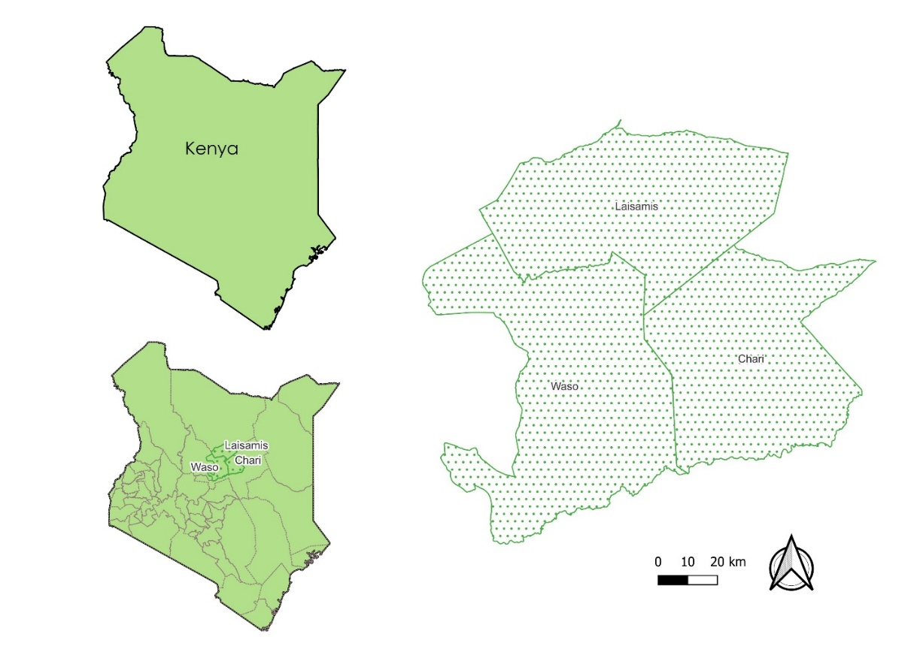

Table 3: Rangeland grazing areas and vegetation types in selected wards
Ward & County | Grazing Units | Median Annual Rainfall (mm) | Vegetation Types |  |  | Total area (km2)
 |  |  | Main Type | Other | Other
Chari, Isiolo | 7 Matokone | 100 to 150 mm | Shrub land (95%), ) | shrub annual grassland (5%), | wooded grassland (small areas) | 2320
Chari, Isiolo | 8 Barchuma | 100 to 150 mm | Shrub grassland (70%), | perennial grassland (25%) | shrub annual grassland (5%), bush land (small areas) | 1950
Chari, Isiolo | 9 Kom | 150 to 225 | Shrub land (50%), | bush land (30%), | dwarf shrub grassland (20%) | 1330
Waso, Samburu | 13b Konya | 275 to 325 | Deciduous shrubland (95%), | deciduous bush grassland (5%) | NA | 5860
Waso, Samburu | 13c Ewaso | 25 to 350 | Deciduous bush grassland (80%), | deciduous shrubland (15%), | deciduous bushland (5%) | 7670
Laisamis Marsabit | 20 Rusarus | 200 | Bushed grassland | riparine woodlands | deciduous shrubland | 1510
 |  |  |  |  | TOTAL | 20,640

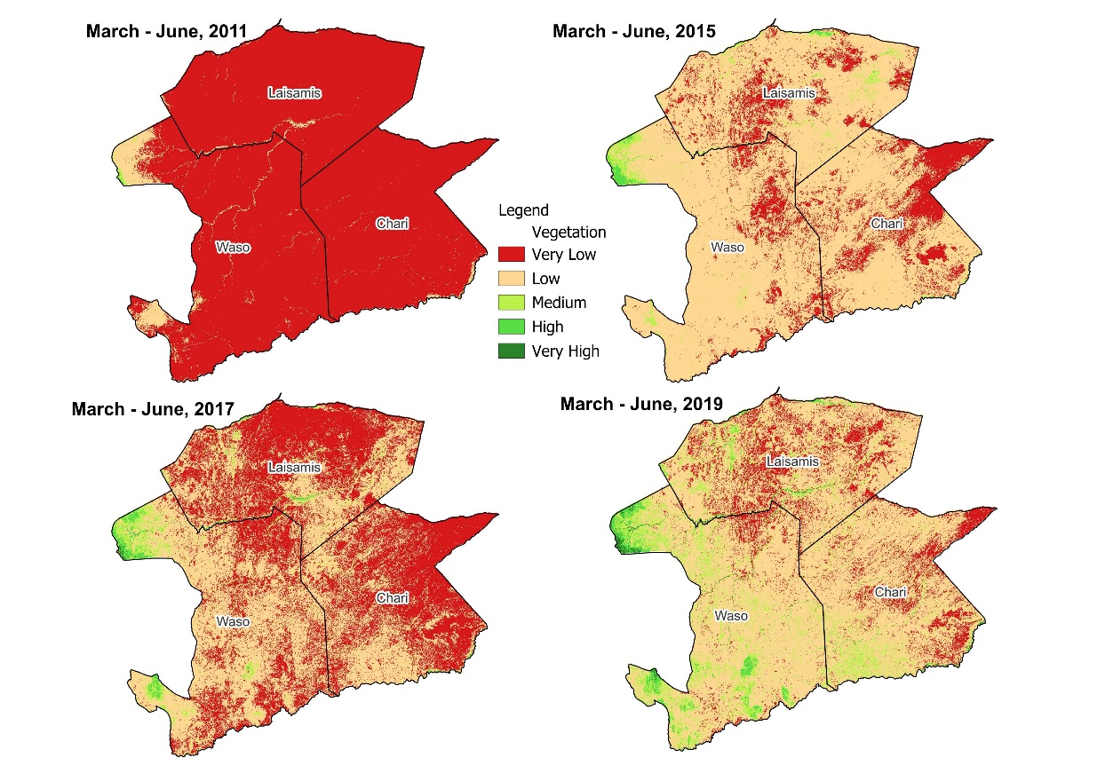
Figure 1: Time series of vegetation cover in Sabarwawa including drought year in 2011 (by WOTR)

Table 4: Calculation of estimated above ground biomass from NDVI values

Variable | Ward | 2011 | 2015 | 2017 | 2019 | 2021 | 2022 | 2023 | 2024
AGB (B tons) | Laisamis | 0.02 | 37.39 | 42.90 | 131.30 | 163.09 | 129.17 | 758.02 | 590.35
AGB (B tons) | Waso | 7.52 | 108.50 | 258.14 | 710.18 | 953.18 | 512.70 | 1352.49 | 1635.33
AGB (B tons) | Chari | 0.71 | 6.13 | 13.40 | 105.06 | 98.68 | 102.45 | 862.74 | 266.33
Mean NDVI | Laisamis | 0.06 | 0.13 | 0.10 | 0.13 | 0.14 | 0.14 | 0.20 | 0.19
Mean NDVI | Waso | 0.08 | 0.13 | 0.13 | 0.18 | 0.19 | 0.17 | 0.21 | 0.22
Mean NDVI | Chari | 0.07 | 0.11 | 0.10 | 0.14 | 0.14 | 0.15 | 0.22 | 0.18
Max. NDVI | Laisamis | 0.24 | 0.44 | 0.60 | 0.81 | 0.77 | 0.73 | 0.77 | 0.60
Max. NDVI | Waso | 0.40 | 0.49 | 0.74 | 0.86 | 0.81 | 0.82 | 0.80 | 0.65
Max. NDVI | Chari | 0.33 | 0.47 | 0.56 | 0.81 | 0.76 | 0.74 | 0.76 | 0.62

Figure 2: Ward-wise estimation of aboveground biomass in Sabarwawa landscape during drought years between 2011 and 2024 (analysis prepared by WOTR)
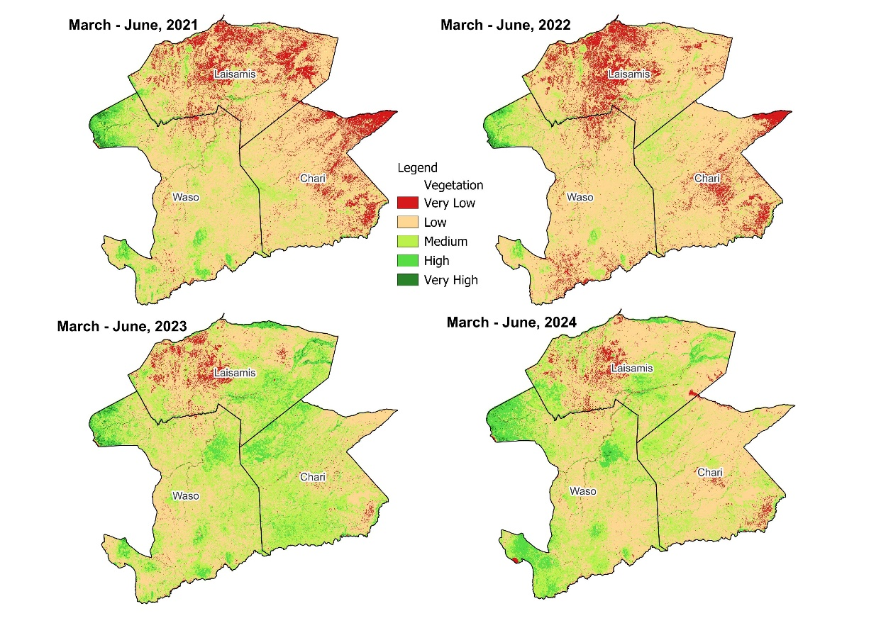
Figure 3: Time series of vegetation cover in Sabarwawa including drought year in 2022 (by WOTR)

Table 5: Time horizons and input values for improved valuation of selected benefit flows
Benefit | Parameters for initial valuation of benefit flow | 2022 | 2025 | 2027 | 2029 | 2050
Access to water | Increased capacity of storage tanks & pans (market value of water)  Increased recharge to springs & wells due to improved range vegetation and management (SWAT) (market value of water) | Baseline | Mid-term | Project completion | 1st Ex-post evaluation | Longer time horizon
Vegetation conditions | Market value of gum & resin  Market value of carbon (not accessible as of 2025)
Livestock | Meat production value  Camel milk production value

.

